**Christopher King**

**2018141521058**

**Mechanical Design 2**

**Class Section 01**

**11/05/2021**

# **Problem 1**

A full journal bearing has a shaft journal diameter of 25 mm with a unilateral tolerance of -0.01 mm. The bushing bore has a diameter of 25.04 mm with a unilateral tolerance of 0.03 mm. The l⁄d ratio is unity. The bushing load is 1.25 kN, and the journal rotates at 1200 rev/min. Analyze the minimum clearance assembly if the average viscosity is 50 mPa-s to find the minimum oil film thickness, the power loss, and the percentage of side flow.

**Solution:**

Known:

Therefore,

Shaft average pressure:

Sommerfeld Number:

Figure 12-16: minimum film thickness variable

Therefore, minimum film thickness:

Figure 12-18: coefficient of friction variable

Therefore, coefficient of friction:

Journal friction torque:

Power loss:

Figure 12-20: flow ratio (the percentage of side flow)

# **Problem 2**

A sleeve bearing supports a load of 700 lbf and has a journal speed of 3600 rev/ min. Bearing length is 1.25-in and diameter is 1.25-in as well. An SAE 10 oil is used having an average temperature of 160°F. Using Raimondi–Boyd charts (Fig. 12-16 as shown below), estimate the radial clearance for minimum coefficient of friction f and for maximum load-carrying capacity W. The difference between these two clearances is called the clearance range. Define the range per your clearance.

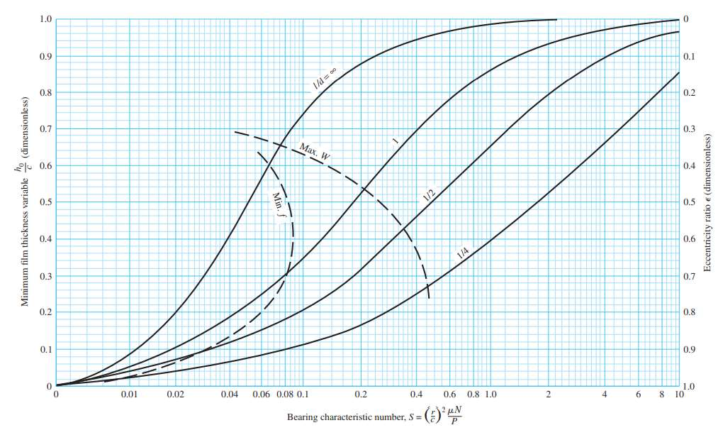

**Solution:**

Prof. Sui told us we don’t need to do this question.

# **Problem 3**

A full journal bearing has a shaft diameter of 3.000 in with a unilateral tolerance of -0.0004 in. The bushing has a bore diameter of 3.003 in with a unilateral tolerance of 0.0012 in.

Lubricant used in bearing is the SAE 40 oil, which is supplied to the bearings at pump pressure of 60 psig.

The l/d ratio of the full bearing is unity. However, the bearing has a central axial-groove and its width is 20 percent of the full bearing width.

The radial bearing load is 1200 lbf while the shaft is rotating at 1800 rpm.

1. What is the full range of the diametric clearance? (10 points)
2. Calculate (1) the average film temperature, (2) the peak film pressure, (3) the minimum film thickness, (4) the heat loss rate, and (5) the lubricant side-flow rate under the following clearance conditions:
   * + minimum clearance, and
     + maximum clearance.

Iterate till temperature between two iterations are within 5 degF. Tabulate the calculated parameters versus corresponding clearance. Compare characteristics of your data to the trends in Figure 12-25 and outline your observations. (20 points)

1. What is the required capacity of the oil pump to prevent the bearing from starvation within the designed bearing clearance range? (10 points)
2. It is intended to maintain the sump temperature at 150degF during operation and an oil cooler is used to remove the heat from returning oil. Specify the required capacity of the oil cooler within the designed bearing clearance range. (10 points)
3. Use Trumpler’s design criteria to evaluate the minimum film thickness and oil temperature rise of the designed journal bearing. Judge whether the bearing will survive the operation or not. (10 points)

**Solution:**

Known:

Lubricant: SAE 40 oil.

However, the bearing has a central axial-groove and its width is 20 percent of the full bearing width.

1. Therefore,

The full range of the diametric clearance:



Shaft average pressure:

**[minimum clearance]**

Initial guess: average film temperature .

SAE 40 oil viscosity:

Sommerfeld Number:

Figure 12-16: eccentricity ratio

Figure 12-18: coefficient of friction variable

Estimated side flow oil temperature:

2nd Iteration: revised film temperature .

SAE 40 oil viscosity:

Sommerfeld Number:

Figure 12-16: eccentricity ratio

Figure 12-18: coefficient of friction variable

Estimated side flow oil temperature:

3rd Iteration: revised film temperature .

SAE 40 oil viscosity:

Sommerfeld Number:

It is divergent. Hence, initial guess: average film temperature .

SAE 40 oil viscosity:

Sommerfeld Number:

Figure 12-16: eccentricity ratio

Figure 12-18: coefficient of friction variable

Estimated side flow oil temperature:

Initial guess: average film temperature .

SAE 40 oil viscosity:

Sommerfeld Number:

Figure 12-16: eccentricity ratio

Figure 12-18: coefficient of friction variable

Estimated side flow oil temperature:

2nd Iteration: revised film temperature .

SAE 40 oil viscosity:

Sommerfeld Number:

Figure 12-16: eccentricity ratio

Figure 12-18: coefficient of friction variable

Estimated side flow oil temperature:

3rd Iteration: revised film temperature .

SAE 40 oil viscosity:

Sommerfeld Number:

Figure 12-16: eccentricity ratio

Figure 12-18: coefficient of friction variable

Estimated side flow oil temperature:

Therefore, the average film temperature is equal to .

Iteration Table:

|  |  |  |  |  |  |  |
| --- | --- | --- | --- | --- | --- | --- |
| Trial |  |  |  |  |  |  |
|  |  |  |  |  |  |  |
|  |  |  |  |  |  |  |
|  |  |  |  |  |  |  |

Figure 12-21: maximum-film-pressure ratio

The peak film pressure:

The minimum film thickness:

The lubricant side-flow rate:

The heat loss rate:

**[maximum clearance]**

Initial guess: average film temperature .

SAE 40 oil viscosity:

Sommerfeld Number:

Figure 12-16: eccentricity ratio

Figure 12-18: coefficient of friction variable

Estimated side flow oil temperature:

2nd Iteration: revised film temperature .

SAE 40 oil viscosity:

Sommerfeld Number:

Figure 12-16: eccentricity ratio

Figure 12-18: coefficient of friction variable

Estimated side flow oil temperature:

3rd Iteration: revised film temperature .

SAE 40 oil viscosity:

Sommerfeld Number:

Figure 12-16: eccentricity ratio

Figure 12-18: coefficient of friction variable

Estimated side flow oil temperature:

Therefore, the average film temperature is equal to .

Iteration Table:

|  |  |  |  |  |  |  |
| --- | --- | --- | --- | --- | --- | --- |
| Trial |  |  |  |  |  |  |
|  |  |  |  |  |  |  |
|  |  |  |  |  |  |  |
|  |  |  |  |  |  |  |

Figure 12-21: maximum-film-pressure ratio

The peak film pressure:

The minimum film thickness:

The lubricant side-flow rate:

The heat loss rate:

|  |  |  |  |  |  |
| --- | --- | --- | --- | --- | --- |
|  |  |  |  |  |  |
|  |  |  |  |  |  |
|  |  |  |  |  |  |

Comparison: The greater the clearance, the smaller the film temperature, the greater the peak film pressure, the greater the minimum film thickness, the greater the lubricant side-flow rate, and the greater the heat loss rate.

1. **[minimum clearance]**

|  |  |  |  |  |  |  |
| --- | --- | --- | --- | --- | --- | --- |
| Trial |  |  |  |  |  |  |
|  |  |  |  |  |  |  |

Figure 12-21: flow ratio

The required capacity of the oil pump:

**[maximum clearance]**

|  |  |  |  |  |  |  |
| --- | --- | --- | --- | --- | --- | --- |
| Trial |  |  |  |  |  |  |
|  |  |  |  |  |  |  |

Figure 12-21: flow ratio

The required capacity of the oil pump:

1. **[minimum clearance]**

**[maximum clearance]**

1. **[minimum clearance]**

**[maximum clearance]**

Therefore, the bearing will survive the operation.